ENGL 3110 — Bonus Assignment — Spring 2026 — ANSWER KEY
Total Points: 20 • 2 points per sentence

Instructions
For each sentence below, complete two tasks:
1. Complete the labeling table by filling in the Role, Phrase, and Part of Speech (POS) rows.
2. Create a syntax tree diagram using SyntaxTreeHybrid. In the student version, paste or attach your diagram in the space provided. In the answer key, the completed diagram is shown.
Scoring (per sentence): 1 point for a correct labeling table • 1 point for a correct diagram
Abbreviation Key
Parts of Speech | Phrase Types | Roles
Noun = N | Noun Phrase = NP | Subject = Subj
Verb = V | Verb Phrase = VP | Predicate = Pred
Adjective = ADJ | Adjective Phrase = ADJP
Adverb = ADV | Adverb Phrase = ADVP
Pronoun = PRO | Prepositional Phrase = PP
Determiner = DET | Sentence = S
Preposition = PREP

Notes:
- In the Phrase row, label the main verb as VP. The VP label in the table applies to just the main verb itself.
- In the Role row, label the subject noun phrase as Subject and the main verb as Predicate. Leave other cells empty.
- Always include a Phrase-level label for every noun, verb, adjective, adverb, and preposition.
- Determiners (DET) group under the NP — they do not get their own Phrase label.

Sentence 1: (2 pts) The tall student slept quietly in the library.
Role | Subject |  |  | Predicate
Phrase | NP |  |  | VP | ADVP | PP
Word | The | tall | student | slept | quietly | in | the | library
POS | DET | ADJ | N | V | ADV | PREP | DET | N
Bracket notation: [S [NP [DET The] [ADJP [ADJ tall]] [N student]] [VP [V slept] [ADVP [ADV quietly]] [PP [PREP in] [NP [DET the] [N library]]]]]
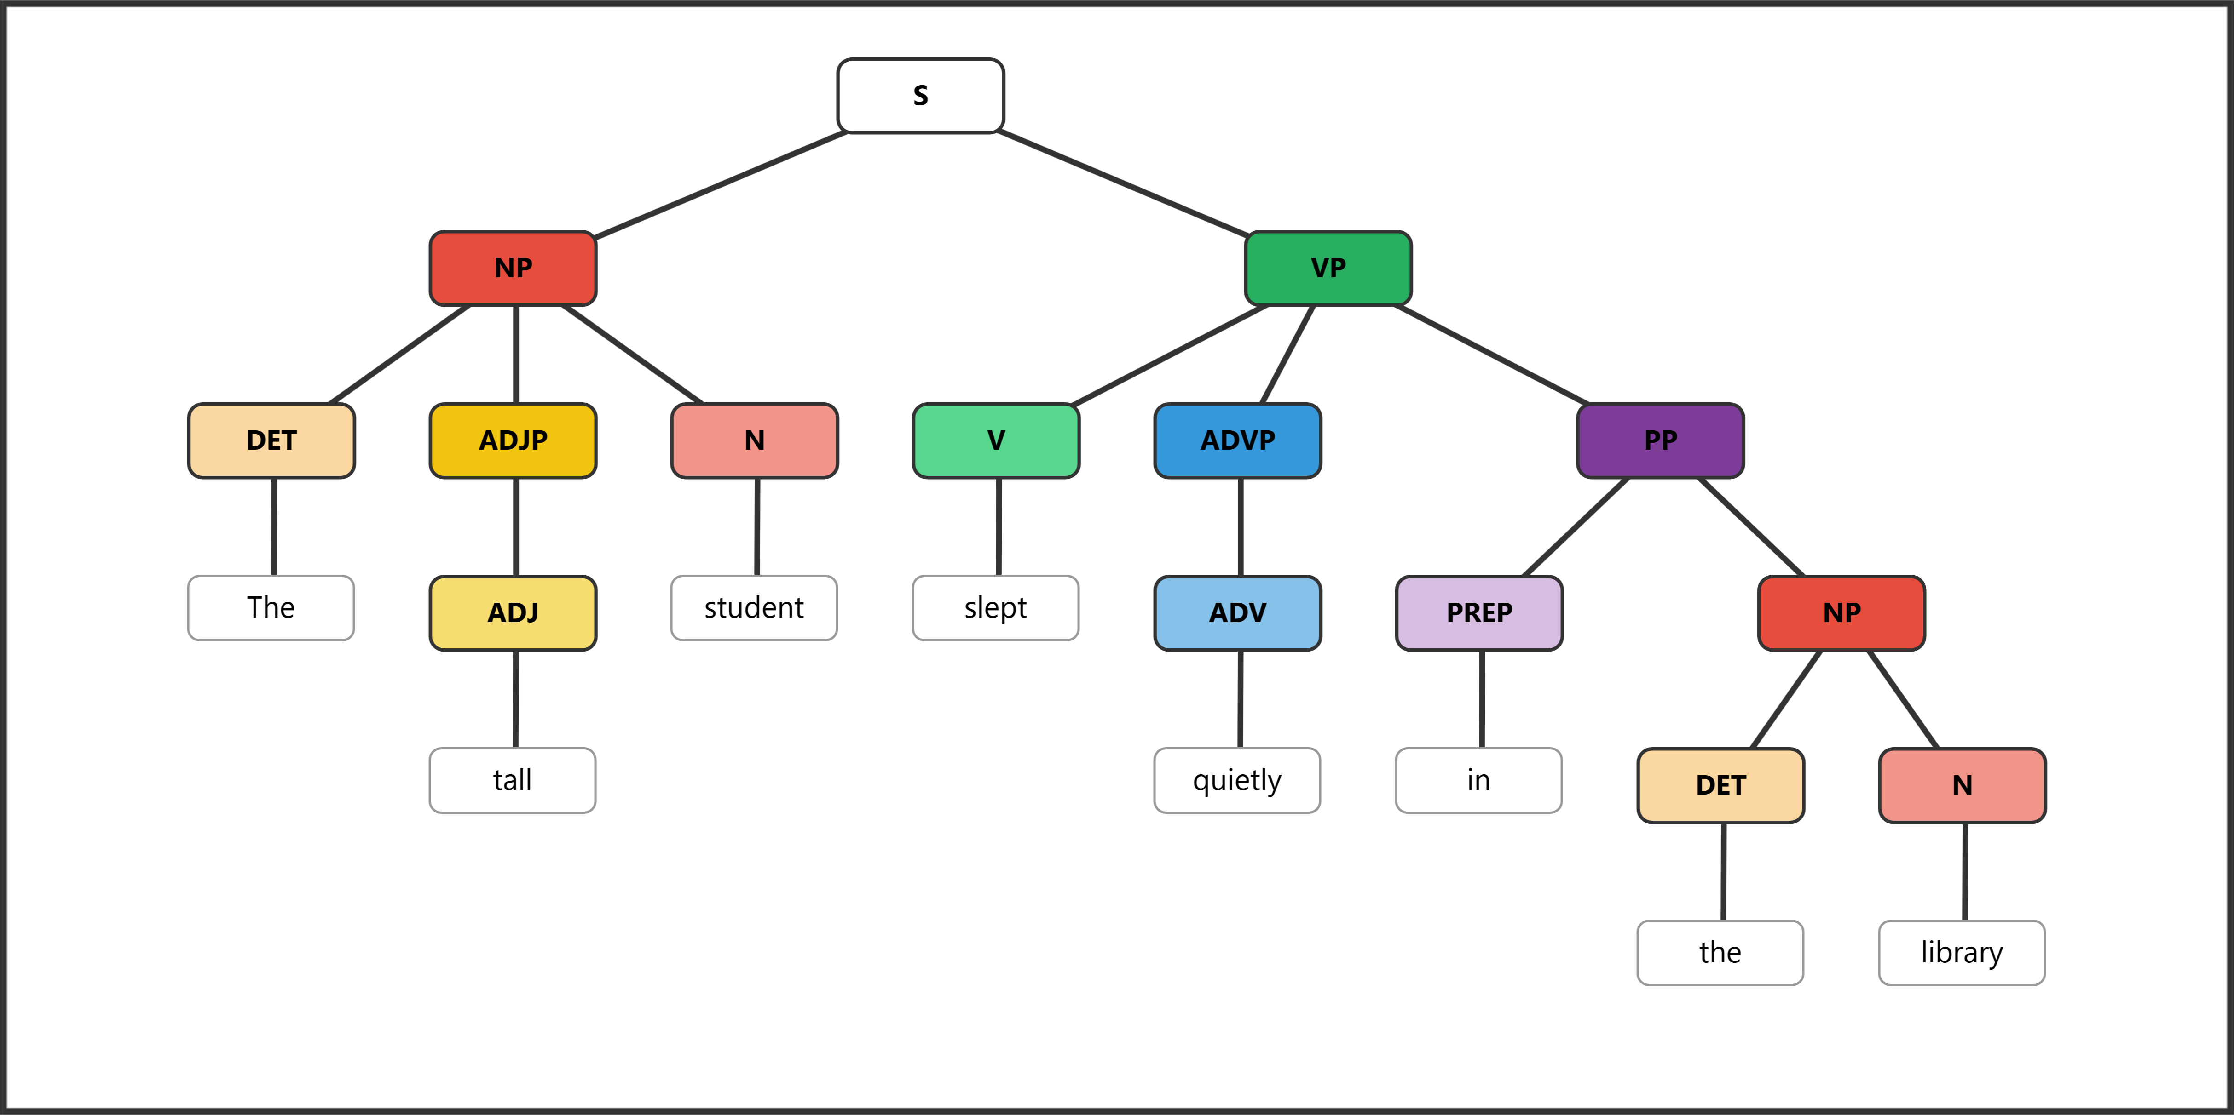

Sentence 2: (2 pts) The young children played happily in the yard.
Role | Subject |  |  | Predicate
Phrase | NP |  |  | VP | ADVP | PP
Word | The | young | children | played | happily | in | the | yard
POS | DET | ADJ | N | V | ADV | PREP | DET | N
Bracket notation: [S [NP [DET The] [ADJP [ADJ young]] [N children]] [VP [V played] [ADVP [ADV happily]] [PP [PREP in] [NP [DET the] [N yard]]]]]
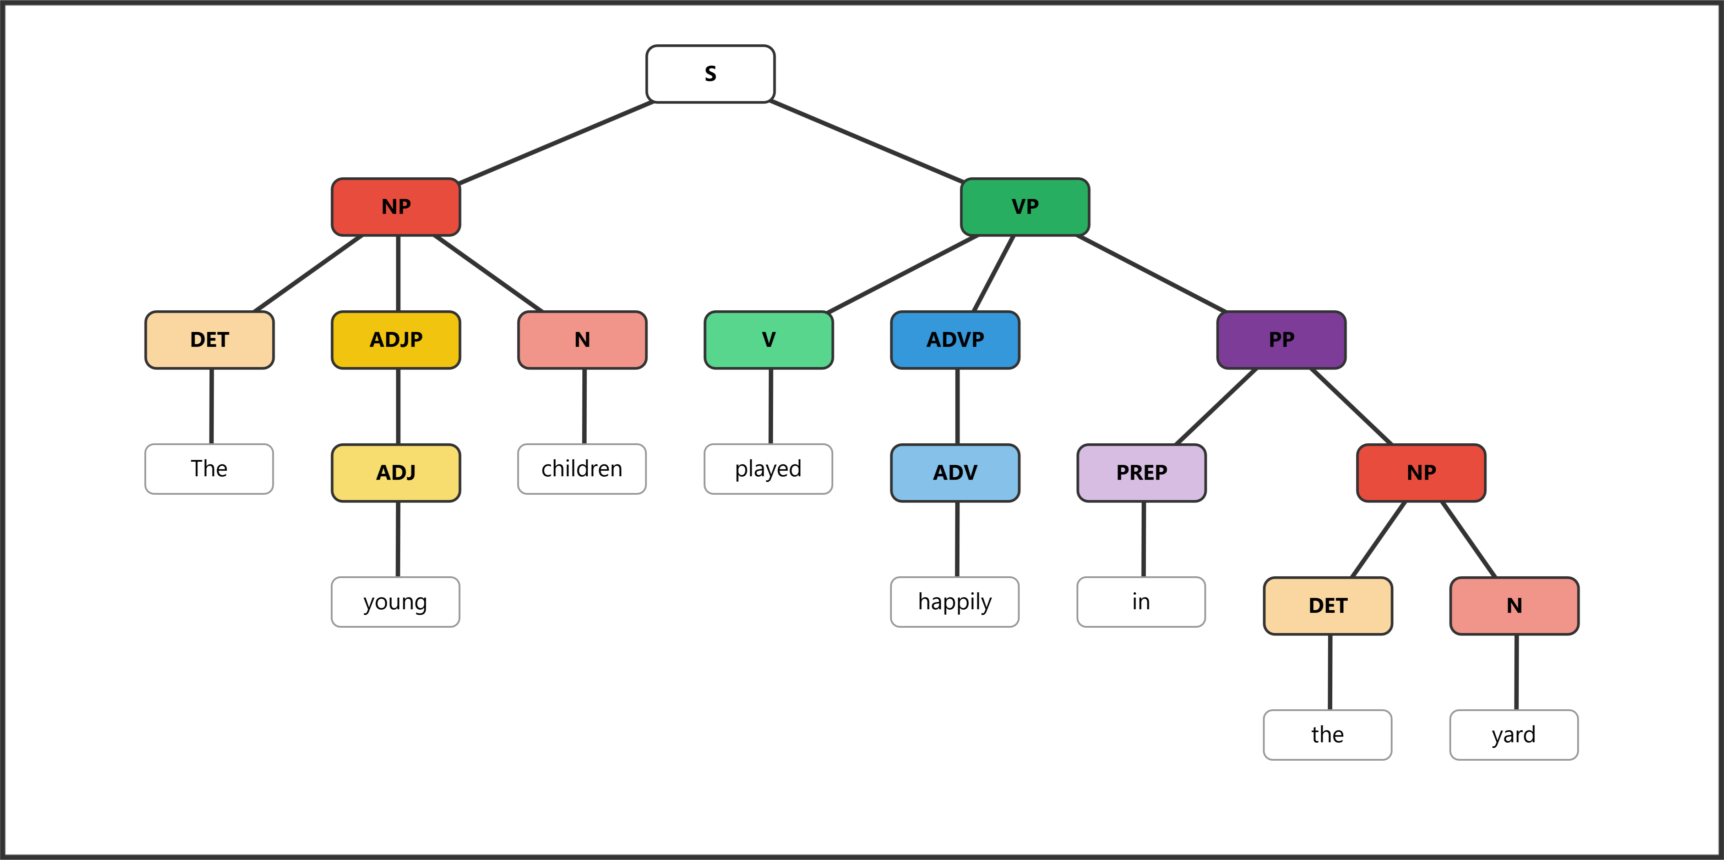

Sentence 3: (2 pts) She ran very quickly through the dark forest.
Role | Subject | Predicate
Phrase | NP | VP | ADVP |  | PP
Word | She | ran | very | quickly | through | the | dark | forest
POS | PRO | V | ADV | ADV | PREP | DET | ADJ | N
Bracket notation: [S [NP [PRO She]] [VP [V ran] [ADVP [ADV very] [ADV quickly]] [PP [PREP through] [NP [DET the] [ADJP [ADJ dark]] [N forest]]]]]
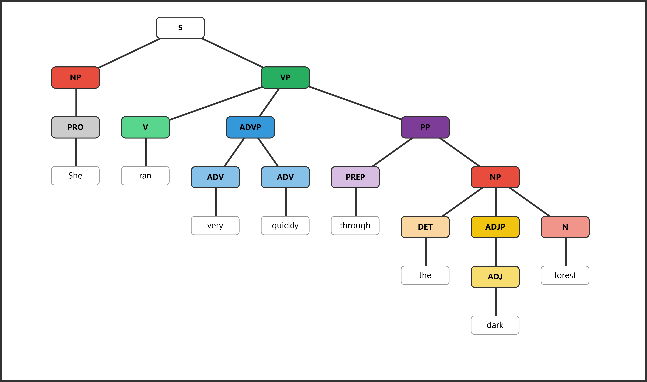

Sentence 4: (2 pts) The old dog rested near the warm fireplace.
Role | Subject |  |  | Predicate
Phrase | NP |  |  | VP | PP
Word | The | old | dog | rested | near | the | warm | fireplace
POS | DET | ADJ | N | V | PREP | DET | ADJ | N
Bracket notation: [S [NP [DET The] [ADJP [ADJ old]] [N dog]] [VP [V rested] [PP [PREP near] [NP [DET the] [ADJP [ADJ warm]] [N fireplace]]]]]
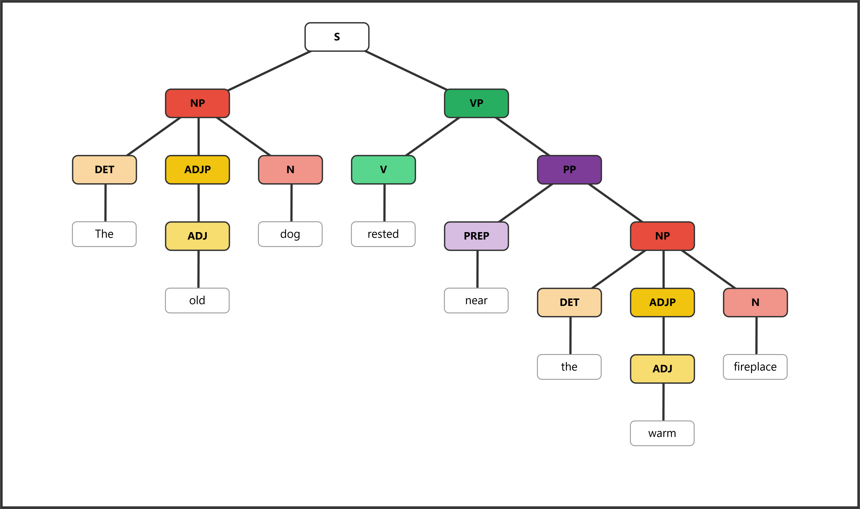

Sentence 5: (2 pts) The bright stars shone above the quiet town.
Role | Subject |  |  | Predicate
Phrase | NP |  |  | VP | PP
Word | The | bright | stars | shone | above | the | quiet | town
POS | DET | ADJ | N | V | PREP | DET | ADJ | N
Bracket notation: [S [NP [DET The] [ADJP [ADJ bright]] [N stars]] [VP [V shone] [PP [PREP above] [NP [DET the] [ADJP [ADJ quiet]] [N town]]]]]
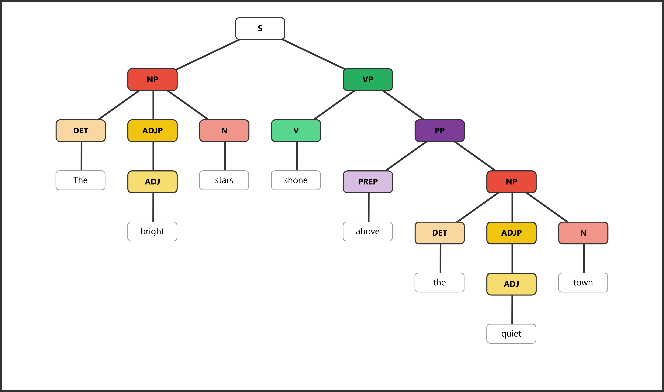

Sentence 6: (2 pts) They walked very slowly along the narrow path.
Role | Subject | Predicate
Phrase | NP | VP | ADVP |  | PP
Word | They | walked | very | slowly | along | the | narrow | path
POS | PRO | V | ADV | ADV | PREP | DET | ADJ | N
Bracket notation: [S [NP [PRO They]] [VP [V walked] [ADVP [ADV very] [ADV slowly]] [PP [PREP along] [NP [DET the] [ADJP [ADJ narrow]] [N path]]]]]
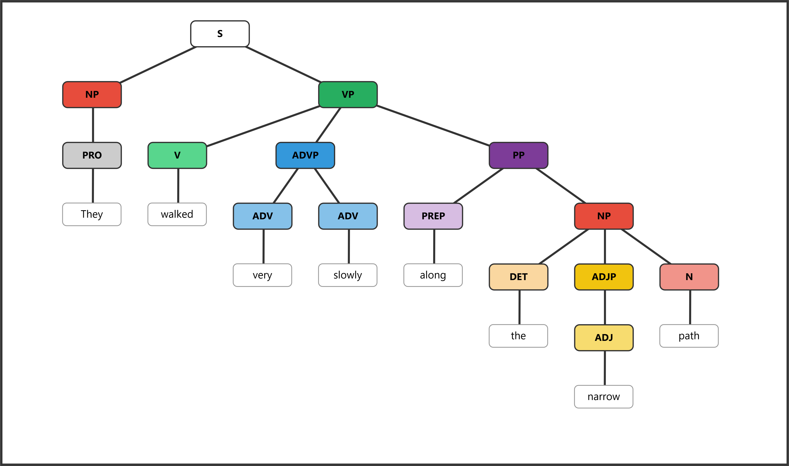

Sentence 7: (2 pts) The nervous professor spoke clearly at the podium.
Role | Subject |  |  | Predicate
Phrase | NP |  |  | VP | ADVP | PP
Word | The | nervous | professor | spoke | clearly | at | the | podium
POS | DET | ADJ | N | V | ADV | PREP | DET | N
Bracket notation: [S [NP [DET The] [ADJP [ADJ nervous]] [N professor]] [VP [V spoke] [ADVP [ADV clearly]] [PP [PREP at] [NP [DET the] [N podium]]]]]
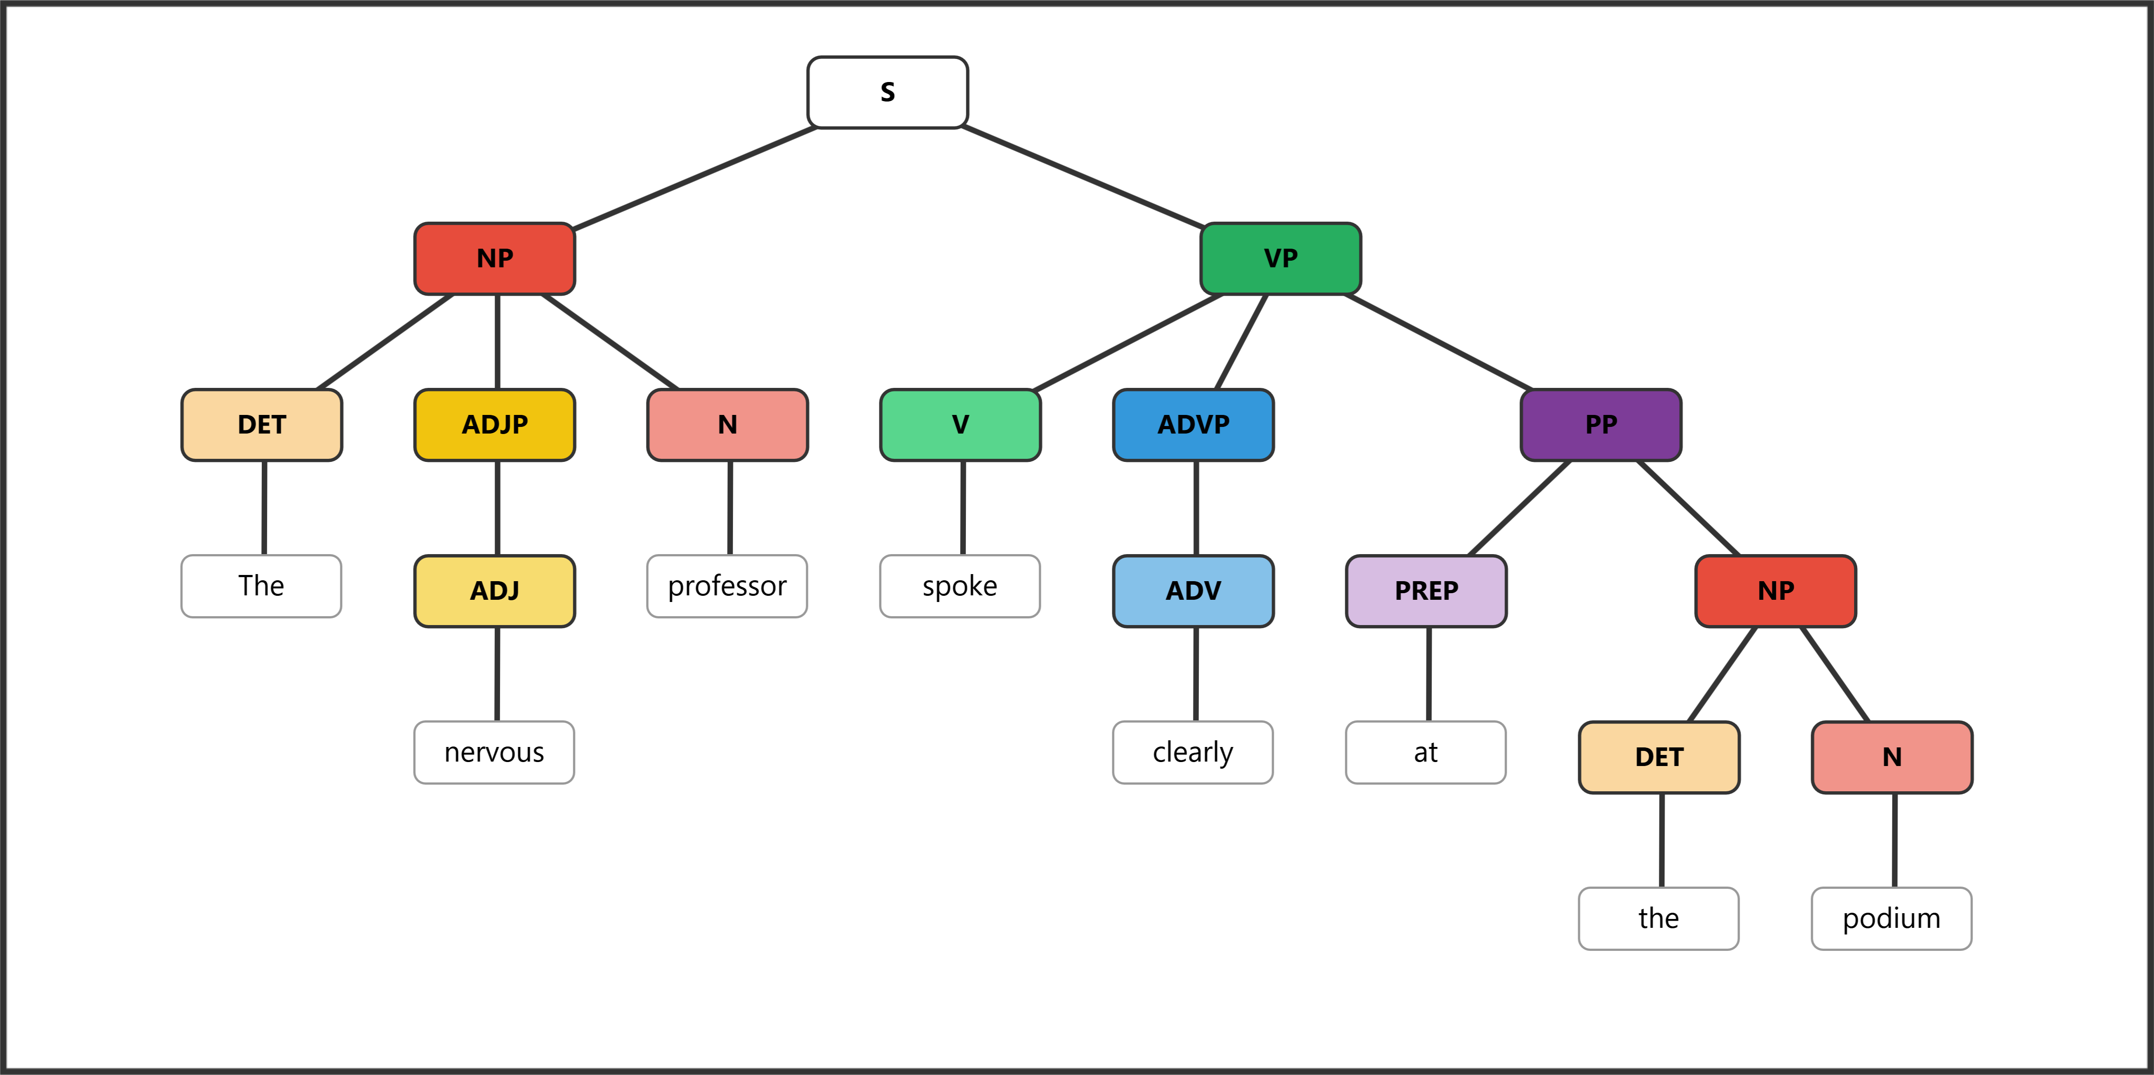

Sentence 8: (2 pts) Small birds sang loudly near the old oak.
Role | Subject |  | Predicate
Phrase | NP |  | VP | ADVP | PP
Word | Small | birds | sang | loudly | near | the | old | oak
POS | ADJ | N | V | ADV | PREP | DET | ADJ | N
Bracket notation: [S [NP [ADJP [ADJ Small]] [N birds]] [VP [V sang] [ADVP [ADV loudly]] [PP [PREP near] [NP [DET the] [ADJP [ADJ old]] [N oak]]]]]
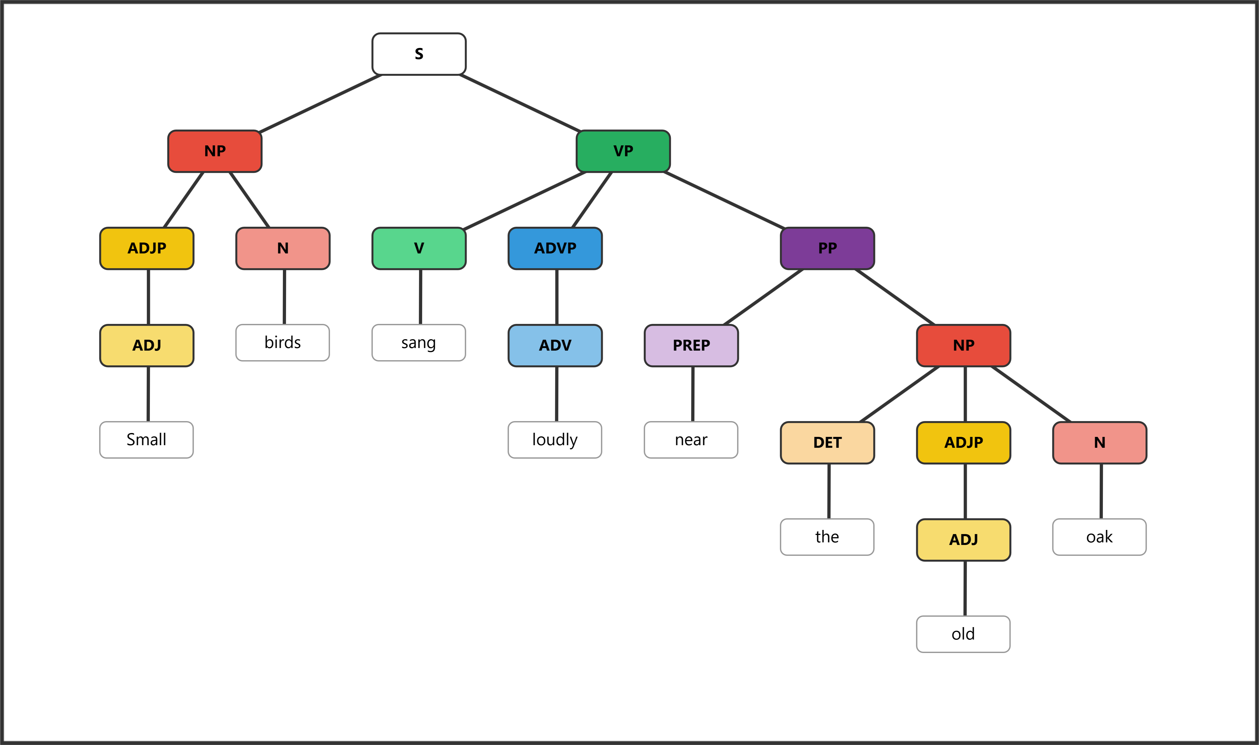

Sentence 9: (2 pts) He waited very patiently outside the large building.
Role | Subject | Predicate
Phrase | NP | VP | ADVP |  | PP
Word | He | waited | very | patiently | outside | the | large | building
POS | PRO | V | ADV | ADV | PREP | DET | ADJ | N
Bracket notation: [S [NP [PRO He]] [VP [V waited] [ADVP [ADV very] [ADV patiently]] [PP [PREP outside] [NP [DET the] [ADJP [ADJ large]] [N building]]]]]
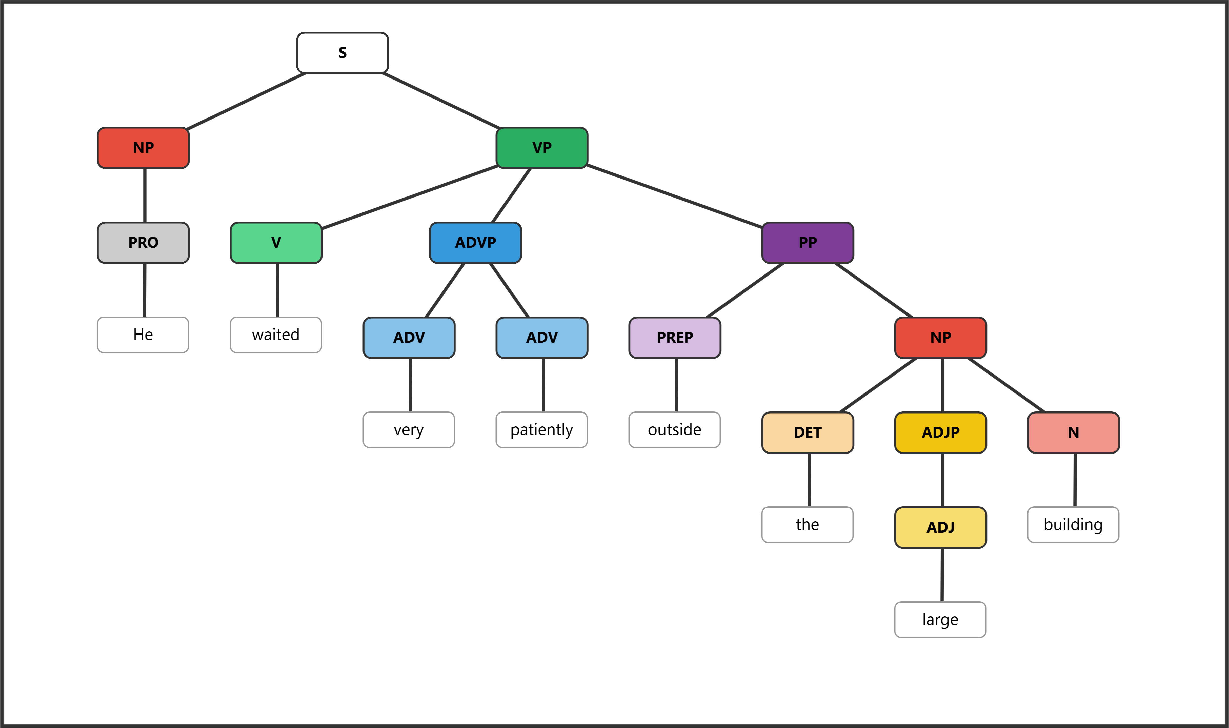

Sentence 10: (2 pts) The tired runner collapsed suddenly at the barrier.
Role | Subject |  |  | Predicate
Phrase | NP |  |  | VP | ADVP | PP
Word | The | tired | runner | collapsed | suddenly | at | the | barrier
POS | DET | ADJ | N | V | ADV | PREP | DET | N
Bracket notation: [S [NP [DET The] [ADJP [ADJ tired]] [N runner]] [VP [V collapsed] [ADVP [ADV suddenly]] [PP [PREP at] [NP [DET the] [N barrier]]]]]
